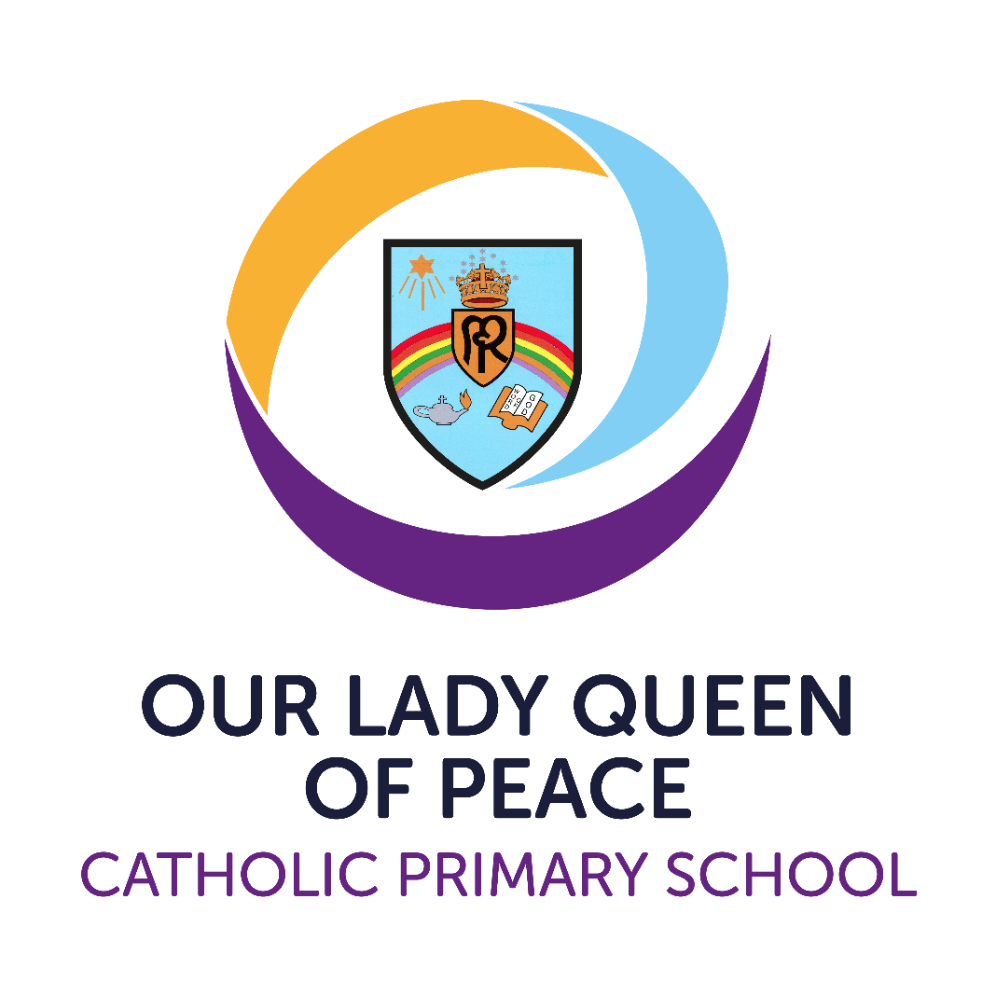
Religious Education Policy

Version | 1
Date created/updated | 16th September 2025
Ratified by | Local Governing Body
Date ratified | October
Date issued | October 2025
Policy review date | September 2026
Post holder responsible | (Executive) Principal
Director / LGB Chairperson | Ben Sheehy

Commitment to Equality:
We are committed to providing a positive working environment which is free from prejudice and unlawful discrimination and any form of harassment, bullying or victimisation. We have developed a number of key policies to ensure that the principles of Catholic Social Teaching in relation to human dignity and dignity in work become embedded into every aspect of school life and these policies are reviewed regularly in this regard.
This policy has been approved and adopted by Our Lady Queen of Peace Catholic Primary School in October 2025 and will be reviewed in September 2026.

Signed by LGB representative for Our Lady Queen of Peace: Ben Sheehy

Signed by (Interim Executive) Principal: Anthony Wilkes

Commitment to Equality
We are committed to providing a positive working and learning environment which is free from prejudice, unlawful discrimination, and any form of harassment, bullying or victimisation. The principles of Catholic Social Teaching on human dignity guide this policy and its implementation across all curriculum areas and phases.

Mission Statement
To Love and to Share, Believe and Achieve
At Our Lady Queen of Peace, we: LOVE each other as God has told us to do. SHARE our Catholic faith and love everyone. BELIEVE that we can grow in God's love. Take pride and celebrate all that we ACHIEVE together
Our school is a caring school where we are ALL valued.

Rationale of Religious Education
In the life of faith of the Catholic school, religious education plays a central and vital part. At the heart of Catholic education lies the Christian vision of the human person. This vision is expressed and explored in religious education. Therefore, religious education is never simply one subject among many, but the foundation of the entire educational process. The beliefs and values studied in Catholic religious education inspire and draw together every aspect of the life of a Catholic school. We are committed to classroom RE, then, because all pupils have the right to receive an overall religious education which will enable them, in the light of the faith of the Church, to engage with the deepest questions of life and find reasons for the hope which is within them (1 Peter 3:15). Religious Education is, then, the core subject in a Catholic school.
At Our Lady Queen of Peace Catholic Primary School, Religious Education is central to the life of the school. The beliefs and values studied in RE inspire and draw together every aspect of the life of our school. In line with the Bishops’ Conference guidance, 10% of teaching time is devoted to RE. This helps to nurture the human wholeness of each pupil to play a full role in society and provides a community in which faith, culture and life are brought into harmony. RE is taught as a discrete subject but is also connected across the wider curriculum where appropriate.

Relationship between Religious Education and Prayer & Liturgy
Following the Prayer & Liturgy Directory (CBCEW, 2023), the term ‘collective worship’ is replaced with ‘prayer and liturgy’. In this policy, ‘celebration of the word’ is used for assemblies centred on Scripture. RE (the academic subject) is distinct from, and complementary to, prayer and liturgy (the school’s communal prayer and liturgical life). Both are essential to the Catholic life of the school and mutually enrich one another.
We continue to fulfil the statutory requirement for a daily act of worship. In our Catholic context and documentation, we describe this as daily prayer and liturgy, expressed in forms appropriate to pupils’ age and the liturgical year.

Aims
- Recognise that everyone is created in the image and likeness of God.
- Foster, deepen and nurture the faith of pupils and staff.
- Promote an understanding and appreciation of Catholic teaching and practice.
- Educate and enrich each individual and develop values that reflect the Gospel message and the teaching of the Church.
- Foster and promote the moral and spiritual development of pupils.
- Promote and encourage active and committed participation and service in the life of the Church and its community.
- Place Christ at the centre of our community.
- Develop a relationship with God by responding to His presence through prayer and reflection.
- Develop knowledge and understanding of the Catholic Faith in partnership with school, home and parish.
- Foster attitudes of respect and understanding for the beliefs and traditions of other faiths and of the global community.

Our Religious Education Curriculum Policy seeks to…
- Promote high standards of teaching and learning in Religious Education.
- Foster an understanding of the Catholic Faith and its links to other Christian and world faiths.
- Recognise that each child is a unique individual able to make a valuable contribution to our school community and to the wider world.
- Encourage pupils to develop their individual skills to the best of their ability.
- Encourage pupils to develop an enquiring attitude to their own faith and that of others.

How we meet our stated aims
- Through a planned curriculum, children learn about the Catholic faith and grow in appreciation of others in the world around them.
- Religious Education is taught as a subject in its own right, accounting for 10% of lesson time across the school, using the Birmingham Diocesan curriculum ‘Learning and Growing as the People of God’.
- ‘Walk with Me’ resources are used during Advent and Lent and support class and whole‑school celebrations, including celebrations of the word.
- We employ a wide range of approaches—writing, investigation, role‑play, discussion, meditation, prayer, music, dance—using whole‑class, group, paired and individual learning.
- All pupils have access to RE irrespective of ability, gender, disability, colour or religion. Tasks are adapted to accommodate all individuals and this is evident in planning.
- All pupils, whether Catholic, Christian or of other/no faith, receive the same RE curriculum and are fully integrated into class life, with equal opportunities to participate (e.g., GIFT Leaders, reading at Mass, offering prayer).
- Assessment focuses follow a rolling programme on the Liturgical Year, Scripture, the Sacraments and Living as Christians, supported by National Age‑Related Standards for RE to track understanding and progression.
- Resources support a range of abilities and include materials for Prayer & Liturgy (including celebrations of the word), sacramental preparation, seasons and feasts of the Church, Saints, multi‑cultural themes, and Scripture. Class libraries include age‑appropriate religious texts and all classes have Bibles.
- Technology is used to enhance and develop the teaching and learning of Religious Education.
- Colleagues support one another in planning and leading prayer and liturgy, inducting new staff, and sharing effective learning and teaching.
- The RE Co‑ordinator engages with diocesan and local networks to share good practice and remain current with guidance.

Spiritual Development (Prayer in School)
Pupils experience a rich life of prayer—formal/traditional prayers of the Church and school day, spontaneous and meditative prayer, and reflective silence. We cultivate a true ‘sense of prayer’ through thoughtful formation and an environment conducive to encounter with God. Prayer may take place in whole‑school, phase or class settings.

Elements of Class Prayer
- Listen to the Word of God: short passages of Scripture from the Bible.
- Praise God: a line from a Psalm or a suitable liturgical acclamation.
- Meditation: quiet time for reflection appropriate to age.
- Intercession: prayers offered by the children or led by the teacher.
- Thanks: expressions of gratitude prompted by Scripture or classroom experience.
- Sorrow: acknowledging the need to say sorry and seek God’s mercy.
- Formal Prayer: taught in accordance with diocesan guidance; pupils learn traditional prayers and understand their meaning (e.g., the Rosary in October, Stations of the Cross in Lent).
Note: Daily class prayer time does not need to be lengthy and may include two or three of the above elements.
- All classes have a focal point for prayer with appropriate religious artefacts and a display that supports pupils’ prayer and liturgy.

Formal / Whole-School Prayers
- Morning prayer – “Father in Heaven”.
- Grace before meals – “Bless us, O Lord…”.
- Grace after meals – “Thank you, God, for the food we have eaten”.
- Afternoon prayer – “God our Father…”.

Prayer and Liturgy
In line with the Prayer & Liturgy Directory, our communal prayer takes a variety of forms throughout the week. Where assemblies are centred on Scripture, they are celebrated as a celebration of the word following the common structure: Gather – Listen – Respond – Go Forth.
Day | Focus
Monday | Whole‑school Celebration of the Word (Gospel focus)
Tuesday | Fortnightly – Whole‑school Mass in church, led by a class
Tuesday | Fortnightly – Whole‑school Singing Praise (celebration)
Wednesday | Phase Prayer and Liturgy (YR & Y1–Y2; Y3–Y4; Y5–Y6)
Thursday | KS2 – Gifts of God Prayer and Liturgy; EYFS/KS1 – individual Class Prayer and Liturgy
Friday | EYFS/KS1 – Gifts of God Prayer and Liturgy; KS2 – individual Class Prayer and Liturgy
- The Liturgical Calendar shapes the planning of prayer and liturgy across the year (e.g., Holy Days of Obligation, Harvest, Advent, Christmas, Lent, Easter).
- Pupils in Year 3 prepare for the Sacraments of Reconciliation and Holy Communion; pupils in Year 6 prepare for Confirmation. Preparation is a partnership between Parish, School and Family.

Participation and Ministries
We foster full, conscious and active participation in age‑appropriate ways. As a school we gather as a liturgical assembly; staff model good participation alongside pupils. Ministries (e.g., readers, musicians, servers, those who prepare the space) serve prayer and liturgy and receive appropriate formation.

Moral and Social Development
- The RE curriculum underpins pupils’ moral development throughout their faith journey.
- Resources and topics are founded on Catholic moral principles; guidance may be sought from the Diocese and Parish Priest.
- Pupils are encouraged to become mature and responsible Christians and are recognised for Gospel‑centred attitudes and service in our weekly celebration and prayer.
- Social development is woven through all curriculum areas and daily life, shaped by Catholic Social Teaching.
- We support local and global charities (e.g., CAFOD, Father Hudson’s Care, Mission Together) and other charitable initiatives.
- Music, Art and Drama are integral to RE and enrich pupils’ learning experiences.

Multi‑cultural Education
- While handing on the Catholic faith and ethos, we teach Christian values that foster respect for all, regardless of race, creed or skin colour.
- Through planned teaching, pupils learn about other cultures and peoples and what it means to be responsible citizens in line with fundamental British Values.
- Across their primary years, pupils learn elements of Judaism, Hinduism, Islam and Buddhism.
In this way, pupils respect other beliefs without compromising the principles of the Catholic faith.

Management and Organisation
The subject leader has responsibility for the development of RE throughout the school.
- Policy writing.
- Planning – ensuring long‑term plans are reviewed in line with the School Development Plan (SDP).
- Evaluating and monitoring teaching and learning in RE.
- Reporting developments to the Principal and link governor.
- Identifying training needs and informing staff of new developments.
- Auditing and purchasing resources following consultation with staff.
Class teachers plan and provide engaging learning, using agreed long‑term plans and implementing the Birmingham Diocesan Curriculum: Learning and Growing as the People of God. The Headteacher oversees implementation, monitoring and evaluation of the RE policy, teaching and learning, and staff training needs. The link governor liaises with the subject leader and the Principal reports to the governing body.

Monitoring and Evaluation
Monitoring follows the school’s schedule. The policy and curriculum planning are evaluated and revised in line with school development. The RE Lead monitors and evaluates the policy and the quality of teaching and learning and reports to the link governor.

Home–School Liaison
We value strong home–school links. RE homework or projects provide opportunities for families to engage with their child’s learning, often linked to units being studied or to sacramental and liturgical seasons. Parents may also be invited to RE lessons and to ‘Stay & Read’ sessions dedicated to Scriptu

